Nutritional Insights Dashboard – Phase 2 Screenshots
Nov 6, 2026, Ethan Temujin Bayarsaikhan
GitHub Repository
https://github.com/etemujin/project2cloud: frontend code in stage2 folder, backend code in stage 1 folder.
Architecture
The dashboard is a static website (HTML, CSS and JavaScript, with Chart.js for the charts) that calls python azure functions. This is for API’s over HTTP with the four endpoints being: health, insights, recipes and clusters. Then it loads and cleans the data sets from the csv, computes averages, corrections and k clusters. Then after that returns a JSON that contains exec time. In Azure the api runs on a function app and the dataset is stored in blob storage and the dashboard is hosted on static web apps all in one RG.
When the page is opened, it calls all the previous end points for the respective parts in the code to then fill in the charts via insights, health for status badge, the clusters for scatter plot, and recipes for the bottom search.
Services
Azure functions host the endpoints as four HTTP triggered py functions, they were developed plus tested locally with azure. Azure blob storage holds the csv, the functions, and the static web app hosts the dashboard files as well as the RG.
The API as well provides services to the dashboard, health reports if the backend is running. Insights returns the macros per diet, recipes counts as well per diet. Recipes returns all recipes filtered by diet, and clusters groups them all into k clusters.

Deployment (Azure Cloud)

Frontend Dashboard
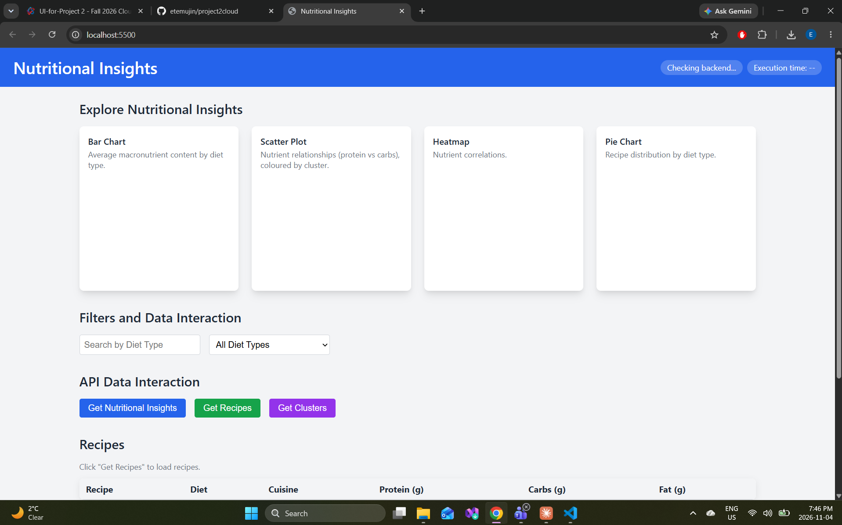Figure 1 – Dashboard layout (sc 3). The layout follows the course skeleton: a header with backend-health and execution-time badges, four chart cards, search and diet filters, three refresh buttons and the recipe table.
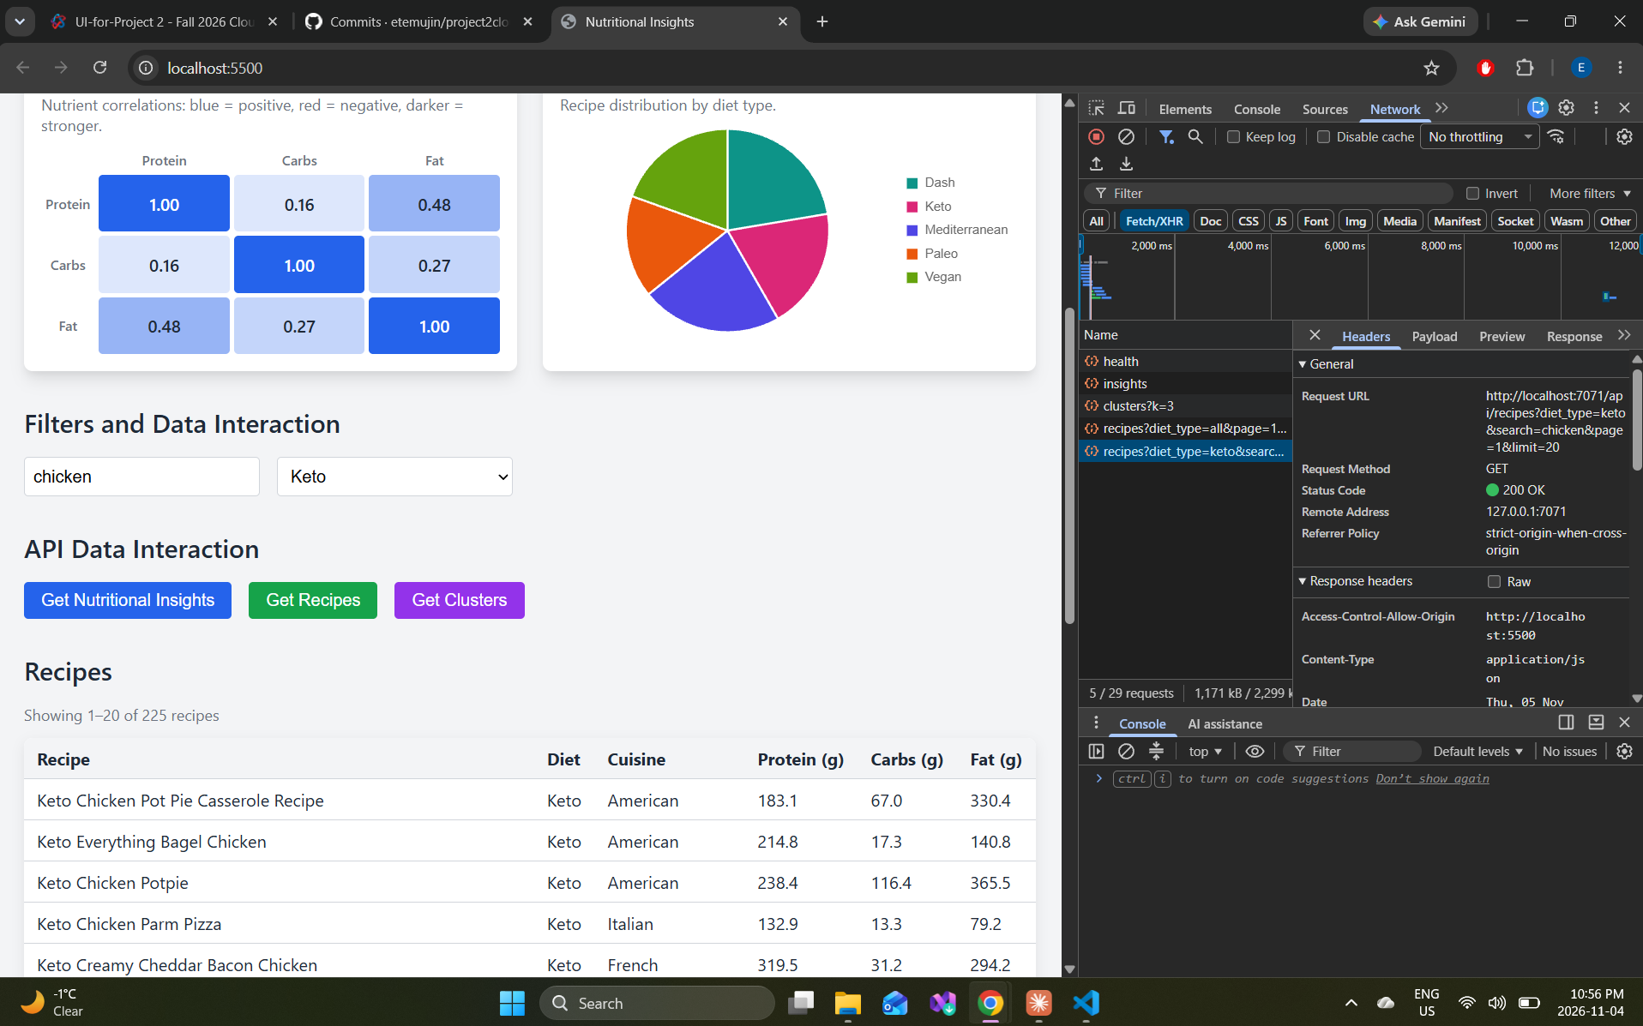Figure 2 – Search, filter and recipe table (sc 9). Searching "chicken" with the Keto filter returns 225 recipes, shown 20 per page. DevTools shows the request URL with its parameters and the CORS header allowing http://localhost:5500.
Data Visualization
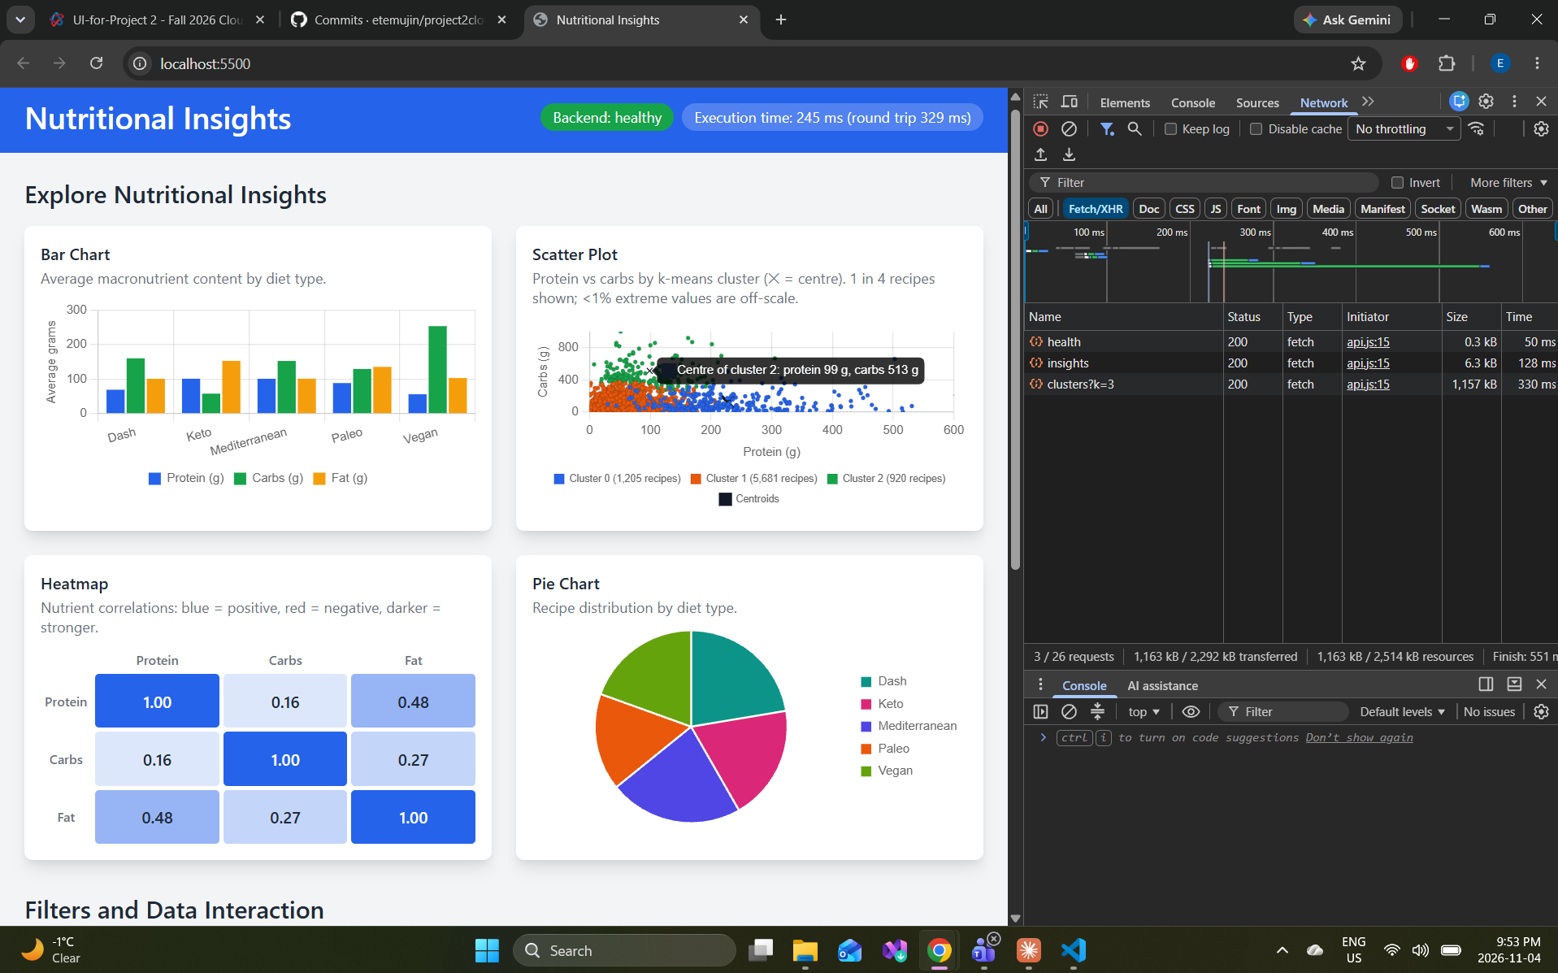Figure 3 – All four visualizations (sc 8). The bar chart, k-means scatter plot (3 clusters, centres marked with ✕), correlation heatmap and pie chart are all drawn from the API. The Network tab shows the health, insights and clusters requests returning 200.
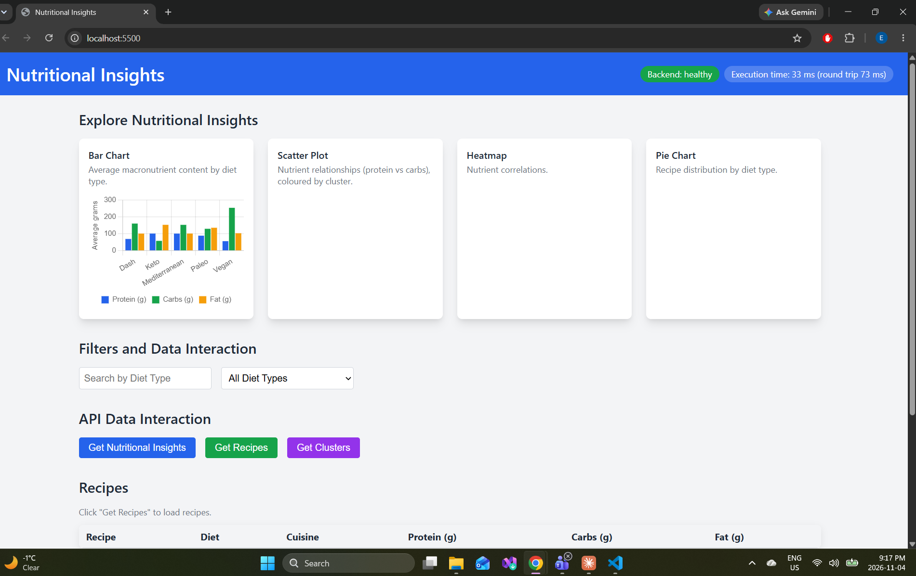Figure 4 – Bar chart (sc 5). Average protein, carbs and fat per diet type, from /insights . Vegan recipes have the most carbs and keto the most fat.
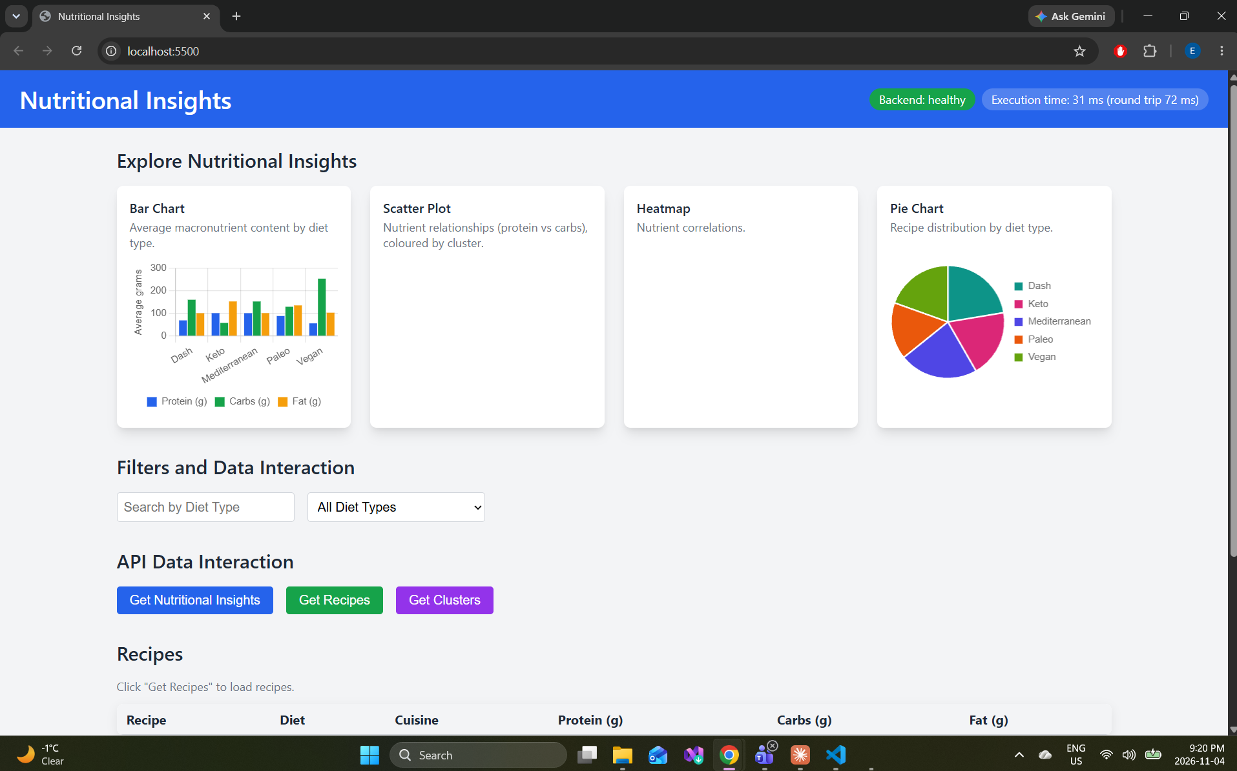Figure 5 – Pie chart (sc 6). Recipe count per diet type, 7,806 recipes in total.
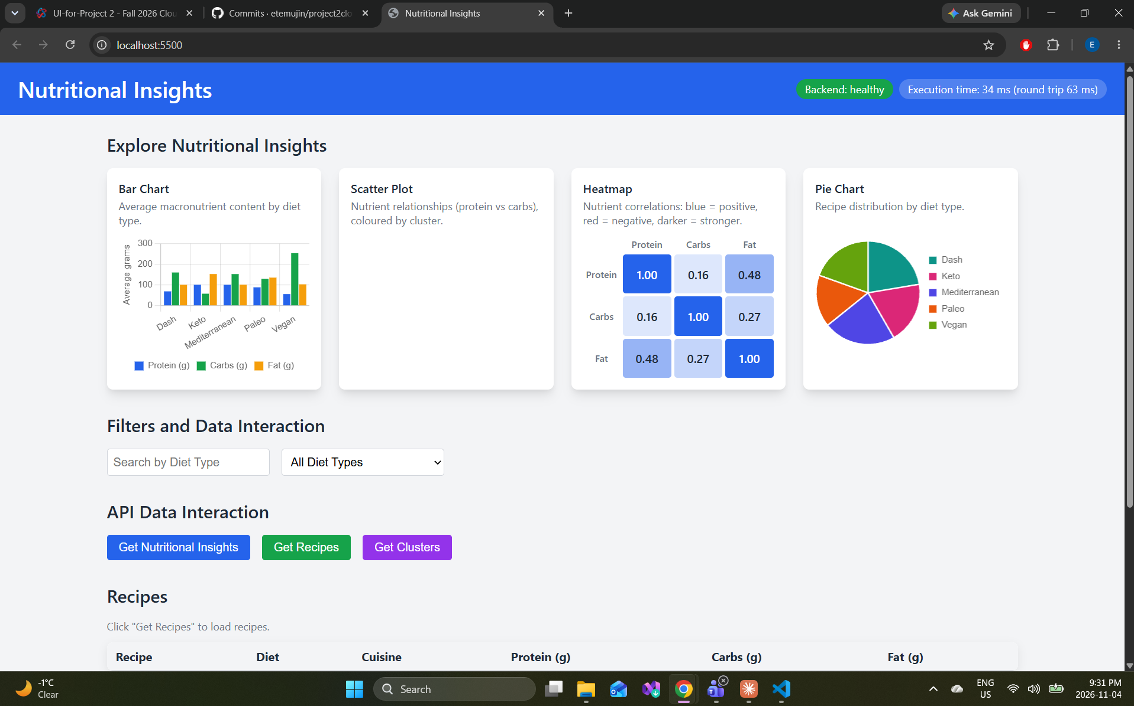Figure 6 – Heatmap (sc 7). Correlations between protein, carbs and fat; protein and fat are the most related (0.48).
Integration
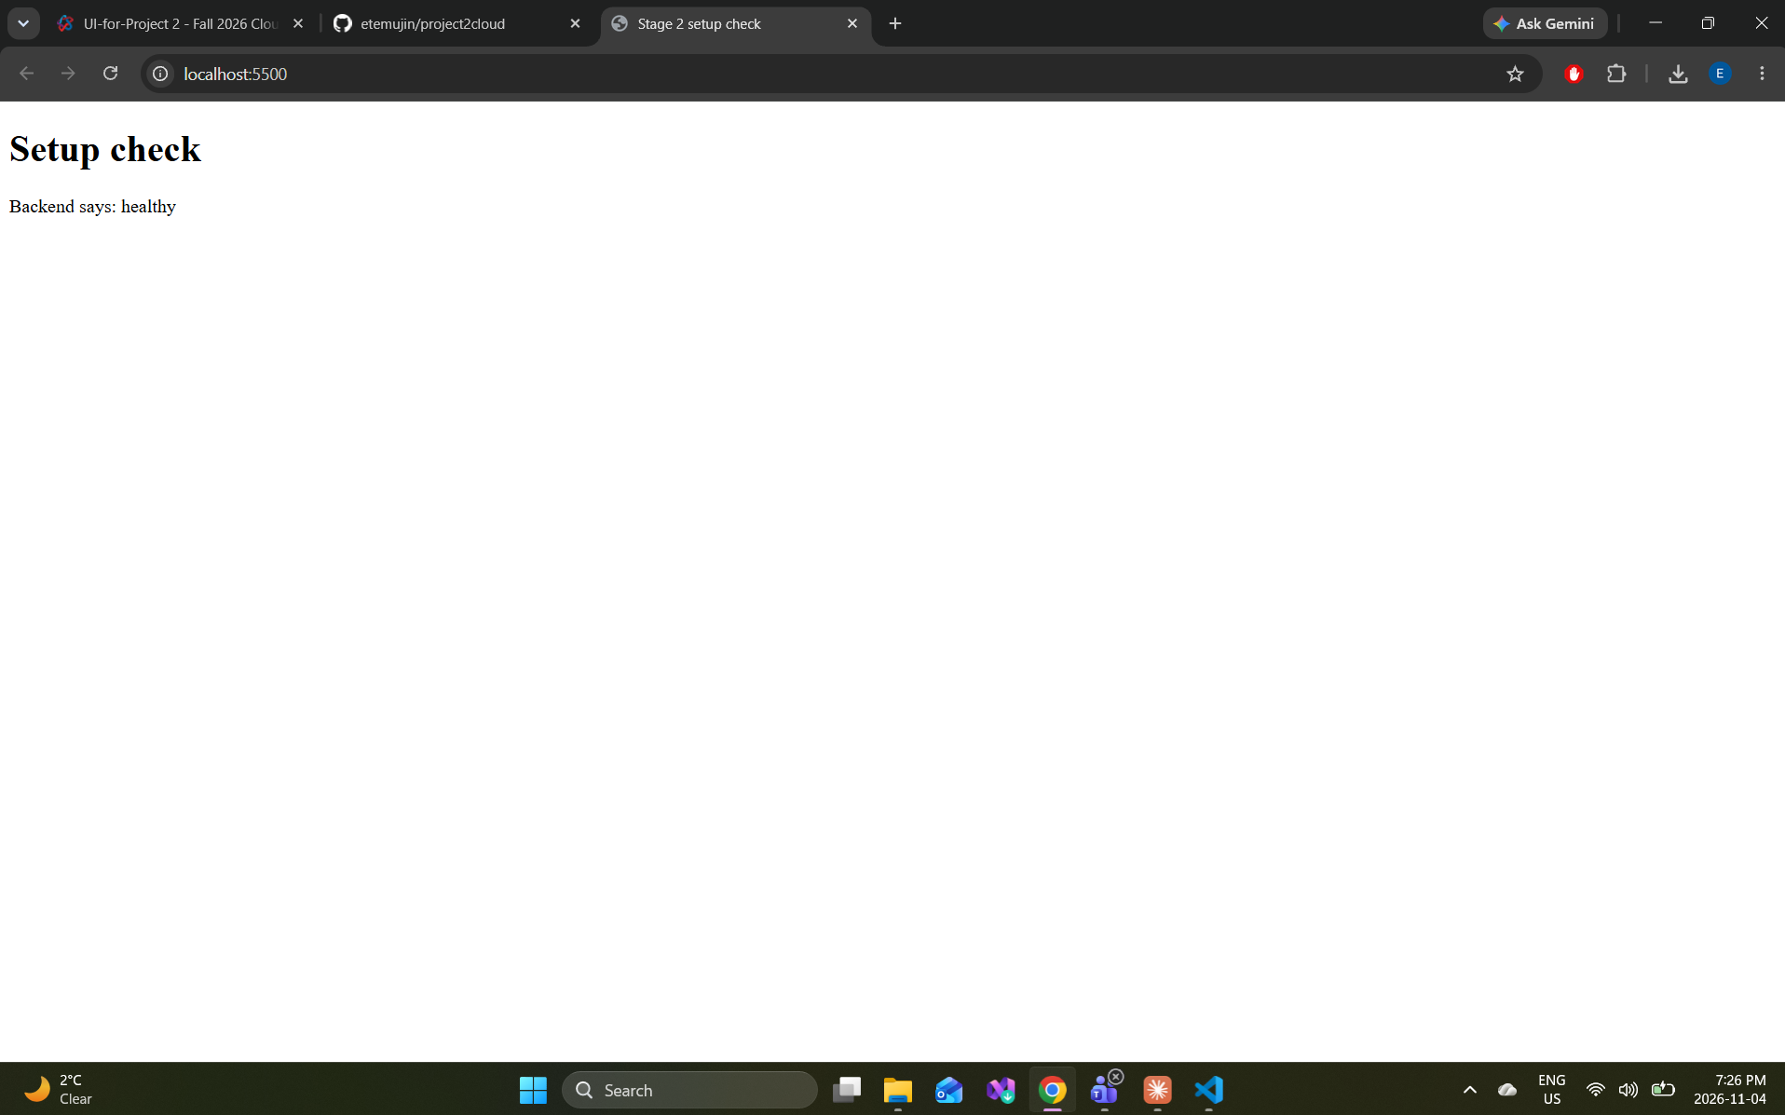Figure 7 – Setup check (sc 1). A first test page on localhost:5500 calls /api/health on the Azure Function and shows its answer, "healthy".
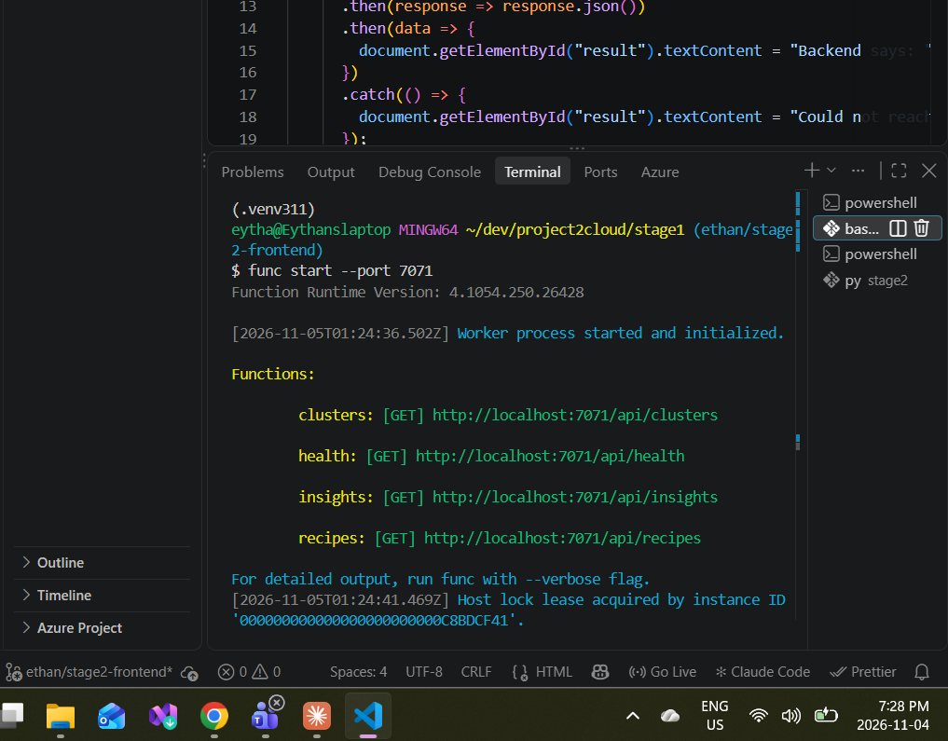Figure 8 – Functions host running (sc 2). func start --port 7071 starts the Azure Functions host and registers the four HTTP routes: clusters, health, insights and recipes.
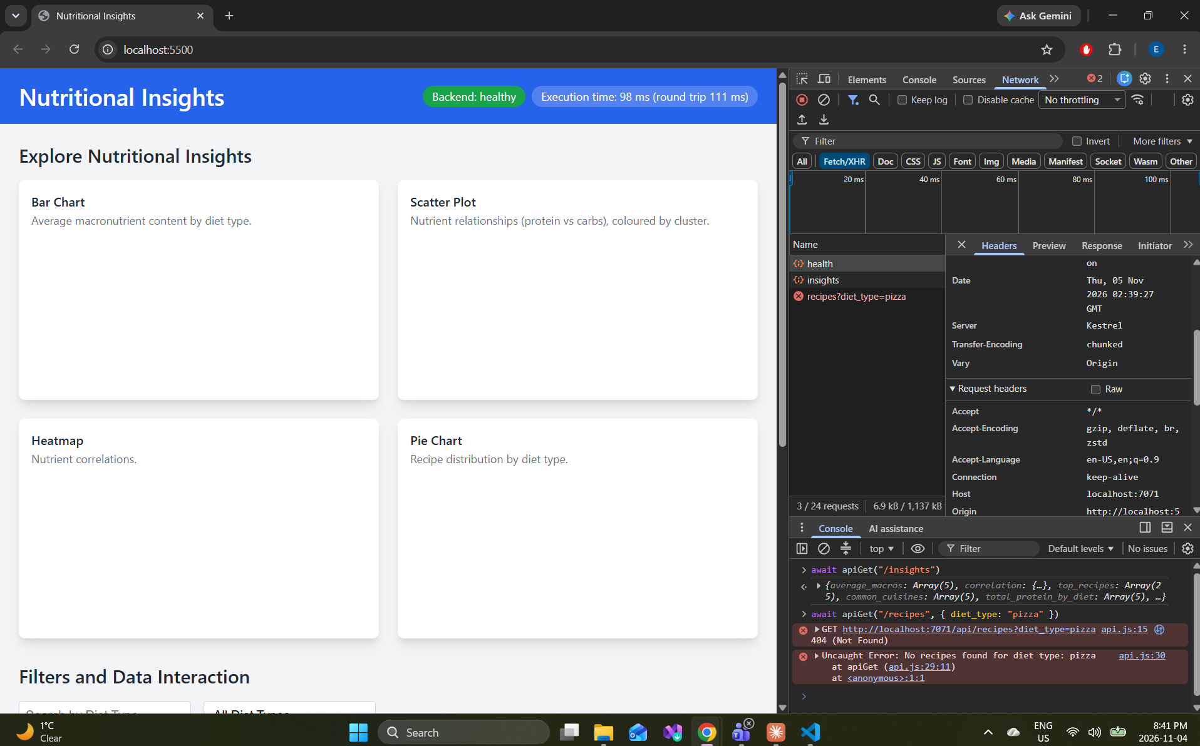Figure 9 – Fetch helper and API errors (sc 4). The health badge turns green, and apiGet() is tested in the console: /insights returns data, and an unknown diet returns a 404 with the message "No recipes found for diet type: pizza".
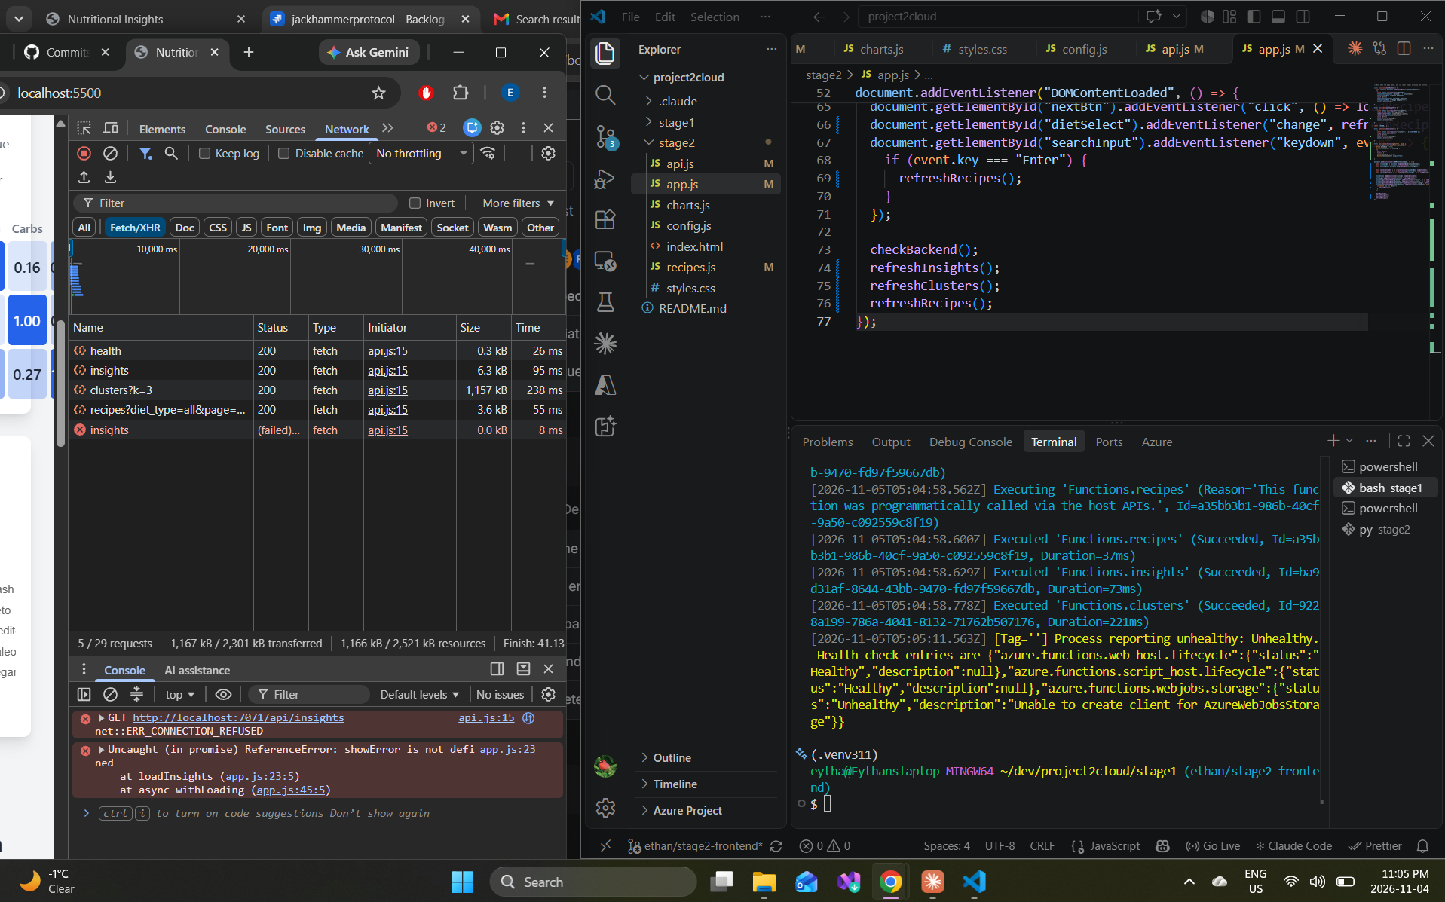Figure 10 – Backend stopped (sc 10). With the Functions host stopped, the insights request fails with ERR_CONNECTION_REFUSED. This was taken before showError() was added; the final version shows a red error banner instead.
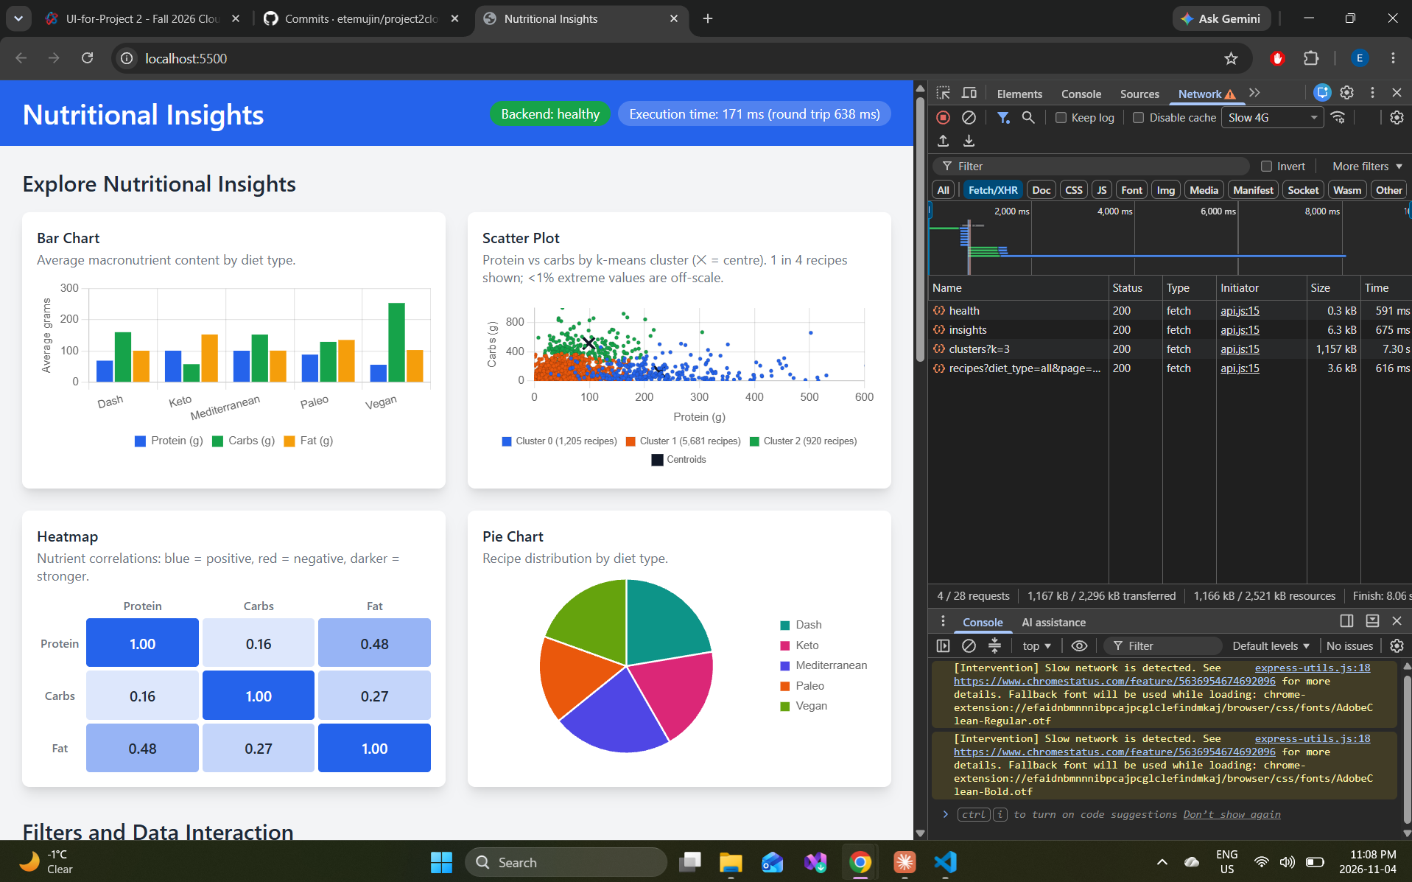Figure 11 – Slow connection (sc 11). On a throttled Slow 4G connection every request still succeeds; the 1,157 kB clusters response takes 7.3 s.

